International Federation of
Orthopaedic Manipulative
Physical Therapists (IFOMPT)
Level 2, The Professional Centre
39 Anzac Road
Browns Bay 0753
Auckland
NEW ZEALAND
Phone: +64 9 476 5353 Fax: +64 9 476 5354
Web: www.ifompt.org

The Role of the External Assessor in the International Monitoring Process

The External Assessor

An External Assessor (EA) is appointed to each Educational programme. The EA assesses the on-going quality of the educational programme and the processes of programme evaluation that are currently in place. The EA will have access to all material related to a programme and its assessments. The EA will sample the students’ evaluations of the various aspects of a programme, as well as conduct interviews with students. This ensures quality but also continuous development of the educational programme.
The EA writes a report every 3 years as a minimum, which is sent to the Member Organisation (MO), indicating whether the educational programme is achieving its aims (and therefore the IFOMPT standards).

Criteria for External Assessors

The EA must:

- Be a member of an MO
- Have an understanding of the requirements of IFOMPT and the Standards Document
- Hold a high degree of an equivalent level or higher to the programme being assessed
- Have teaching and examining experience in Orthopaedic Manipulative Therapy (OMT), ideally at the same level as the programme
- Have some experience of programme development, and in committee work within an educational establishment, or as a programme team member
- Have some experience as a clinical mentor or examiner of OMT

Role of the External Assessor (EA)

The role of the EA is to ensure the theoretical and clinical standards of the educational programme are satisfactory.

They will monitor:
- Standards of written work
- Quality and organisation of the Mentored Clinical Practice (MCP)
- Suitability of the Clinical Mentors
- Standard of the clinical examination
- Overall quality of the educational programme
- Quality of the educational experience
- Quality of the Research project

The EA writes their External Assessor’s report and submits it to the educational programme leader who can respond. The EA also sends the report to the relevant educational committee of the MO, according to their determined time frames. The MO is then responsible for synthesising the information from the educational programmes within their MO, managing any quality issues, and submitting the report as part of its next International Monitoring submission to the Standards Committee of IFOMPT. As displayed in Figures 1 and 2 this is a dynamic process with multidirectional feedback and communication between the EA, educational programme, MO and IFOMPT Standards Committee and Executive. The recommendations and conditions from the IFOMPT Standards Committee and Executive should also be provided back to the EA so that these can be commented on in their next report.

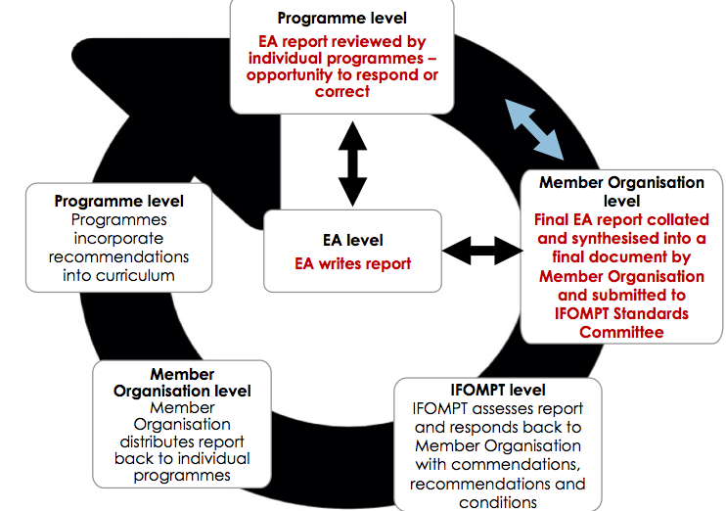

Figure 1 Feedback and Feed-forward Mechanisms between the MO, Educational institutions, IFOMPT Standards Committee/Executive Committee

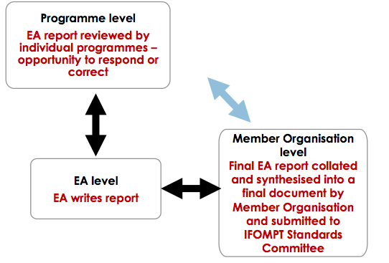

Figure 2 Dynamic multidirectional feedback/communication processes

Aim of the Template for the EA Report
A template for the EA report has been designed to assist MOs in establishing the content required in an EA’s report. Use of this template is not compulsory for all MOs as it is recognised that many MOs have already developed this resource.
Specific aim of template: To further guide MOs in the national processes of Quality Control and Quality Management. Please read alongside Appendix D of the IFOMPT Standards Document: Part B regarding International Monitoring (IM).

Introduction

The report must include a declaration of the independence of the EA. The EA report is required every 3 years as a minimum, which is sent to the MO. In order to make a valid judgement on the programme, the EA report must include:
- An evaluation of the curriculum including progress compared to previous reports.
- Conclusions of correspondence, review and on-site visits with evaluations of teaching, examinations, written assignments, organisational aspects of the educational institution as well as student feedback.

Note: Individual students must not be named

- The Programme Leader is obliged to support the EA in sampling material, course work and data regarding the programme.
- If there is more than one educational programme in an MO, an EA report must be completed for each programme.
- For geographical reasons, the means of evaluation by the EA can be varied e.g. an unedited / live video may be a means of observing assessment processes or MCP.

Sections required in the External Assessor’s Report:

- General data
- Evaluation of the curriculum relating to theory modules and assessments
- Evaluation of curriculum relating to practical skills and assessment
- Evaluation of curriculum relating to evidence-informed practice and application of the process of research
- Evaluation of curriculum relating to mentored clinical practice
- Evaluation of clinical examinations
- Evaluation of the quality of the educational experience
- Conclusions with summary and recommendations

The 8 sections must be completed by answering YES or NO in the middle column. In the right hand column, if the response is NO please provide a full explanation and if the response is YES please provide a full explanation with the supporting evidence or cross-reference to further files (and attach to this report). All questions must be completed with full explanations and supporting evidence.

